AI-powered Interview Assessment Tool

MAIN PROJECT REPORT
Submitted by

AMITH SAHADEVAN PRC22CA006
RAHUL SANDESH PRC22CA022
SHESNA S PRC22CA025

To

APJ Abdul Kalam Technological University
in partial fulfillment of the requirements for the award of B. Tech Degree in Computer Science and Engineering



Department of Artificial Intelligence
Providence College of Engineering, Chengannur OCTOBER 2025



DEPARTMENT OF ARTIFICIAL INTELLIGENCE
PROVIDENCE COLLEGE OF ENGINEERING, CHENGANNUR

CERTIFICATE

Certified that this report entitled ‘AI-powered Interview Assessment Tool’ is the report of the Main Project completed by the following students during 2024-2025 in partial fulfillment of the requirements for the award of the Degree of Bachelor of Technology in Computer Science and Engineering (Artificial Intelligence).

AMITH SAHADEVAN PRC22CA006

RAHUL SANDESH PRC22CA022

SHESNA S PRC22CA025

Dr. Remya R (Project Supervisor)
Associate Professor, Department of Artificial Intelligence

Dr. Prem Sankar C (Project Coordinator & Head of the Department)
Head of the Department of Artificial Intelligence
Providence College of Engineering



DECLARATION
We, hereby declare that this project report entitled ‘AI-powered Interview Assessment Tool’ is the Bonafide work of ours carried out under the supervision of Dr. Remya R, Associate Professor, Department of Artificial Intelligence.
We declare that, to the best of our knowledge, the work reported herein does not form part of any other project report or dissertation on the basis of which a degree or award was conferred on an earlier occasion to any other candidate. The content of this report is not being presented by any other student to this or any other University for the award of a degree.

Sl. No. | Name of Student | Roll Number | Signature
1 | AMITH SAHADEVAN | PRC22CA006
2 | RAHUL SANDESH | PRC22CA022
3 | SHESNA S | PRC22CA025

Dr. Remya R (Project Supervisor)
Associate Professor, Department of Artificial Intelligence

Dr. Prem Sankar C (Project Coordinator & Head of the Department)
Head of the Department of Artificial Intelligence
Providence College of Engineering

Date: 25/10/2025

ACKNOWLEDGEMENTS

We take this opportunity to express our deep sense of gratitude and sincere thanks to all who helped us to complete this project successfully.
We extend our heartfelt gratitude to our project supervisor, Dr. Remya R, for her invaluable support, insights, and encouragement throughout the course of this project. Her guidance has been instrumental in our progress.
We would like to express our sincere thanks to Dr. Prem Sankar C, Head of the Department of Artificial Intelligence, for his overall coordination, timely guidelines, and unwavering support, which have played a significant role in shaping our project.
We are sincerely grateful to our Principal and Providence College of Engineering for providing us with the necessary resources and a conducive academic environment that has greatly contributed to the successful completion of our project.
Finally, we thank our parents, family members, and friends who directly and indirectly contributed to the successful completion of our main project.

AMITH SAHADEVAN

RAHUL SANDESH

SHESNA S

Date: 25/10/2025

ABSTRACT

The modern recruitment landscape poses significant challenges for companies, as the influx of high application volumes renders traditional screening processes slow, costly, and inefficient. Conventional methods, such as resume reviews and manual interviews, are fundamentally limited, as they often fail to capture critical aspects of a candidate’s profile, including soft skills, communication abilities, and professional demeanor. These gaps lead to subjective evaluations, inconsistent standards, and missed opportunities to identify high-potential candidates, resulting in prolonged hiring cycles and increased operational expenses. This project addresses these shortcomings by proposing an AI-powered Interview Assessment Tool designed to revolutionize initial candidate screening through automation and standardization. The system leverages a multi-modal, agent-based architecture to deliver a comprehensive evaluation, aligning with the growing demand for objective hiring practices in a competitive market.
The proposed tool conducts voice-based interviews, engaging candidates in an interactive format where an AI interviewer poses questions and analyzes responses in real-time. At its core, the system employs a sophisticated framework featuring specialized agents that process diverse data streams. The Verbal Agent uses Natural Language Processing (NLP) techniques, such as sentence transformers and spaCy, to assess the content, relevance, and coherence of spoken answers. The Vocal Agent applies speech analysis tools like Librosa and Audio Spectrogram Transformer (AST) to evaluate vocal delivery, focusing on pitch, pace, and confidence indicators. Meanwhile, the Non-Verbal Agent leverages computer vision technologies, including OpenCV, MediaPipe, and Deepface, to interpret body language, facial expressions, and eye contact, capturing subtle cues of professionalism and engagement. These agents operate in parallel, ensuring efficient processing of multimodal inputs.
The outputs from the agents are aggregated by a Scoring & Reporting Engine, which applies a weighted algorithm to fuse the data into a single, holistic performance score out of 200 points, divided between Answer Accuracy (maximum 100 points) and Confidence (maximum 100 points). This engine generates a detailed feedback report, including category breakdowns and actionable insights, which is delivered to the hiring manager via a user-friendly interface. By reducing reliance on human judgment, the tool minimizes biases inherent in traditional methods, such as favoritism or cultural misunderstandings, while accelerating decision-making. The system’s design supports scalability and maintainability, with secure data handling compliant with standards like GDPR, making it a robust solution for enhancing the efficiency, reliability, and fairness of the hiring process.
Keywords: Artificial Intelligence, HR Technology, Recruitment, Multimodal Emotion Recognition, Computer Vision, Natural Language Processing (NLP), Speech Analysis, Candidate Screening.

TABLE OF CONTENTS

ACKNOWLEDGEMENTS i
ABSTRACT ii
LIST OF FIGURES vi
LIST OF TABLES vii
LIST OF ABBREVIATIONS viii
CHAPTER 1 1
INTRODUCTION 1
  - Background 1
  - Existing System 1
  - Gaps Identified 2
  - Problem Statement 2
  - Objectives 2
  - Scope………………………………………………………………………………
CHAPTER 2 3
LITERATURE REVIEW 3
2.1 AI-Based Interview Evaluation……………………………………………………
2.2 Multimodal Emotion Recognition ……………………………………………….
2.3 Technologies for Long-Sequence and Audio Analysis…………………………..
2.4 Privacy and Security in LLMs
CHAPTER 3 6
SYSTEM ANALYSIS 6
  - Expected System Requirements 6
  - Feasibility Analysis 7
  - Hardware Requirements 7
  - Software Requirements 7
  - Life Cycle Used 8
  - Cost Estimation
  - Project Scheduling using Gantt Chart
CHAPTER 4 10
METHODOLOGY 10
  - Proposed System Architecture 10
  - Modular Decomposition 10
  - Scoring System 10
  - Datasets for Training 11
CHAPTER 5 12
SYSTEM DESIGN 12
  - Architectural Diagram 12
  - Data Flow Diagram 13
  - Use Case Diagram 14
  - Sequence Diagram 15
  - Sequence Diagram 16
REFERENCES 25

 | LIST OF FIGURES
Figure number | Figure Name | Page Number
Figure 3.1 | Incremental Model | 2
Figure 3.2 | Gantt chart | 8
Figure 5.1 | System Architecture | 9
Figure 5.2 | Data Flow Diagram (DFD) | 10
Figure 5.3 | Use Case Diagram | 12
Figure 5.4 | Sequence Diagram | 13

 | LIST OF TABLES
Table Number | Table Name | Page Number
Table 3.1 | List and Estimated Price of Components | 8
Table 3.2 | COCOMO model coefficients | 9
Table 7.1 | Test Summary | 22

 | LIST OF ABBREVIATIONS
Abbreviation | Expansion
AI | Artificial Intelligence
NLP | Natural Language Processing
LLM | Large Language Model
CNN | Convolutional Neural Network
API | Application Programming Interface
TTS | Text-to-Speech
STT | Speech-to-Text
GPU | Graphics Processing Unit
CPU | Central Processing Unit
RAM | Random Access Memory
SSD | Solid State Drive

CHAPTER 1 INTRODUCTION

Background
In today's fiercely competitive job market, companies are confronted with the formidable challenge of screening an ever-increasing volume of applications, often reaching into the thousands for a single role. This surge in applicant numbers has rendered traditional recruitment processes slow, expensive, and resource-intensive, placing significant pressure on Human Resources (HR) departments worldwide. Conventional methods, such as manual resume reviews, initial phone screenings, and in-person interviews, are time-consuming and labor-intensive, requiring HR professionals to sift through extensive documentation and conduct preliminary assessments to narrow down candidate pools. These approaches, while effective for verifying documented qualifications and technical skills, struggle to keep pace with the demands of modern hiring, where speed and scalability are critical to securing top talent before competitors do. Moreover, the financial burden of prolonged recruitment cycles—estimated to cost companies between $4,000 and $20,000 per hire depending on the role—further underscores the need for more efficient alternatives.
The HR industry is increasingly turning to Artificial Intelligence (AI) as a transformative solution to address these challenges and gain a competitive edge in talent acquisition. AI technologies, powered by machine learning, natural language processing (NLP), and computer vision, offer the potential to revolutionize recruitment by automating repetitive tasks that traditionally consume significant time and resources. For instance, AI can rapidly parse resumes, extract relevant skills, and rank candidates based on predefined criteria, reducing the initial screening phase from days to hours. This automation not only alleviates the workload on HR teams but also cuts operational costs, allowing organizations to redirect funds toward strategic priorities such as employee development or employer branding. Beyond efficiency, AI provides data-driven insights that enhance decision-making, enabling HR professionals to analyze patterns in candidate performance, predict success rates using historical hiring data, and identify gaps in the talent pipeline with greater accuracy than manual methods allow.
Additionally, AI facilitates the standardization of evaluation criteria, ensuring a consistent and objective assessment of all applicants regardless of the volume or diversity of submissions. By focusing on measurable metrics—such as skill alignment, problem-solving ability, or communication proficiency—AI minimizes the influence of unconscious bias that can creep into human judgments, promoting a more equitable hiring process. This is particularly valuable in today’s diverse workforce, where inclusivity is a priority for attracting and retaining talent. Furthermore, AI enhances the candidate experience by introducing personalized interactions, such as AI-driven chatbots that answer queries or schedule interviews 24/7, and simulated assessments that evaluate soft skills through voice or video analysis. These innovations not only improve candidate satisfaction but also provide valuable feedback, positioning companies as forward-thinking employers.
However, the adoption of AI in recruitment is not without considerations. The effectiveness of these systems hinges on the quality and diversity of training data, as biased datasets can perpetuate existing prejudices. Initial implementation costs, including hardware, software, and staff training, may also pose challenges, particularly for smaller organizations. Despite these hurdles, the long-term benefits—improved efficiency, cost savings, and better hiring outcomes—make AI an indispensable tool for modern HR strategies. As the job market continues to evolve, AI stands poised to redefine talent acquisition, enabling organizations to identify and select candidates with unprecedented precision and agility, ultimately shaping a more competitive and capable workforce.

Existing System
Traditional recruitment methods, such as manual resume reviews and preliminary phone screenings, are characterized by significant limitations that hinder their effectiveness in today’s dynamic job market. These approaches rely heavily on evaluating a candidate’s documented qualifications and technical skills, which are typically derived from resumes, cover letters, or brief verbal exchanges during initial screenings. For instance, HR professionals assess factors such as educational background, years of experience, certifications, and specific technical proficiencies (e.g., proficiency in programming languages or software tools) to determine a candidate’s eligibility. While these metrics provide a foundational understanding of a candidate’s hard skills, they offer a narrow and incomplete picture of their overall potential. The primary shortcoming of these methods lies in their complete failure to evaluate crucial soft skills—such as communication, confidence, and professional demeanor—which are increasingly recognized as strong predictors of job success across diverse industries.
Effective communication, for example, is essential for fostering collaboration, resolving conflicts, and conveying ideas clearly to teams or clients, making it a vital attribute in roles ranging from customer service to project management. Confidence enables individuals to take initiative, handle high-pressure situations, and inspire trust, qualities that are particularly valuable in leadership or sales positions. Professional demeanor, encompassing aspects like adaptability, emotional intelligence, and a polished presentation, enhances a candidate’s ability to represent an organization positively and navigate workplace relationships. Research, including insights from the Society for Human Resource Management (SHRM), suggests that soft skill deficiencies account for up to 89% of hiring failures, underscoring their importance. Yet, traditional methods lack the tools or frameworks to systematically assess these qualities, relying instead on subjective impressions from short phone conversations or written documents, which are prone to inconsistency and bias.
This significant gap in evaluation creates a critical challenge for organizations. Candidates who excel on paper—boasting impressive credentials or technical expertise—may lack the interpersonal abilities required to thrive in a role, leading to potential mismatches. For instance, a highly skilled engineer with poor communication skills might struggle to collaborate on team projects, while a technically proficient salesperson lacking confidence could fail to build client relationships. Such disparities can result in reduced productivity, increased team tension, or elevated turnover rates—estimated at 10-20% in many sectors—incurring substantial costs for retraining or rehiring. Additionally, the reliance on static resumes and brief screenings often overlooks well-rounded candidates whose soft skills compensate for less conventional qualifications, perpetuating a narrow talent selection process.
The inefficiencies of these traditional methods are further exacerbated by the high volume of applications in the current job market, where HR teams are inundated with submissions that overwhelm manual review capabilities. Phone screenings, typically lasting 10-15 minutes, provide limited insight into a candidate’s behavior under diverse scenarios and are insufficient for gauging long-term fit. This combination of limited scope and scalability not only delays hiring timelines but also risks alienating top talent who expect a more engaging and responsive process. Consequently, the existing system fails to meet the evolving demands of modern recruitment, highlighting the urgent need for innovative, technology-driven solutions that can bridge the gap between technical qualifications and interpersonal competence, ensuring a more comprehensive and effective talent acquisition strategy.

Gaps Identified

Lack of Unified Systems: Most tools are fragmented, analyzing verbal, vocal, or non-verbal cues separately instead of providing one holistic assessment.

Keyword Dependency: Systems often rely on simple keyword matching, failing to understand the deeper context, relevance, or creativity of a candidate's answer.

Superficial Soft Skill Analysis: The evaluation of soft skills (like communication or confidence) lacks depth, offering generic feedback rather than actionable insights.

Static Conversation Flow: Interviews follow a rigid, pre-scripted path, unable to adapt, ask follow-up questions, or explore topics dynamically like a human interviewer.

Unaddressed Algorithmic Bias: Many platforms use training data that is not diverse, leading to biased evaluations that can unfairly disadvantage certain groups of candidates.

Problem Statement

The traditional interview process is inherently inefficient and unreliable, primarily due to its heavy reliance on human subjectivity, inherent biases, and inconsistent evaluation standards. Interviewers, influenced by personal experiences, cultural backgrounds, or unconscious prejudices, often make decisions based on subtle cues like appearance or demeanor rather than merit, leading to disparities in assessments. This subjectivity frequently results in poor hiring decisions, where highly capable candidates with strong potential are overlooked due to superficial judgments, while less suitable individuals advance based on charisma or familiarity bias. Such outcomes contribute to higher turnover rates, reduced team productivity, and increased recruitment costs, as organizations struggle to match talent effectively with role requirements.

Compounding these issues is the lack of standardization, where evaluation criteria vary across interviewers or departments, making it difficult to ensure fairness or comparability. In high-volume recruitment scenarios, this inefficiency exacerbates delays, with manual screenings taking days or weeks, allowing competitors to snatch top talent. There is a critical need for an objective, automated system that can fairly and consistently assess both the verbal content of a candidate's answers—evaluating relevance, depth, and articulation—and their non-verbal communication skills, such as body language, facial expressions, and vocal tone. By standardizing and streamlining the initial screening phase through AI-driven analysis, this system would mitigate biases, accelerate decision-making, and enhance overall hiring accuracy, ultimately fostering more equitable and effective talent acquisition.

Objective
- Conduct Voice-Based Interviews: To create an interactive AI interviewer that poses tailored questions (technical, behavioral, situational) using natural text-to-speech. It will then transcribe and analyze the candidate's spoken responses in real-time using speech-to-text.
- Analyze Non-Verbal Cues: To evaluate a candidate's non-verbal communication, including facial expressions, eye contact, and posture, using computer vision (OpenCV, MediaPipe). This will gauge confidence, demeanor, and interpersonal skills.
- Analyze Vocal Tone: To assess communication style by analyzing vocal patterns (pitch, pace, clarity, filler words) using libraries like Librosa. This provides a nuanced understanding of the candidate's vocal confidence and articulation.
- Provide Automated, Unbiased Feedback: To generate a comprehensive, data-driven report scoring the candidate's performance across verbal, vocal, and non-verbal dimensions. This report will use a weighted algorithm to ensure fairness and provide actionable insights and a final score.

Scope

The project aims to develop an innovative AI-powered Interview Assessment Tool designed to enable candidates to participate in a simulated interview experience, mirroring real-world hiring scenarios. This system will serve as a transformative solution for initial candidate screening by leveraging advanced technology to evaluate performance comprehensively. The core functionality includes capturing both video and audio inputs during the interview, allowing the system to record a candidate’s spoken responses and visual cues in a controlled, virtual environment. Utilizing this multimodal data, the tool will perform a detailed analysis across multiple dimensions, assessing the candidate’s abilities holistically rather than relying on isolated metrics.

The scope encompasses the development of distinct analytical agents, each specializing in a specific aspect of communication. The verbal content agent will employ natural language processing (NLP) techniques, such as those powered by spaCy, to evaluate the accuracy, relevance, and depth of the candidate’s answers, focusing on content quality and knowledge demonstration. The vocal analysis agent, leveraging libraries like Librosa, will assess speech patterns, including pitch, pace, clarity, and the presence of filler words, to gauge communication style and confidence levels. Meanwhile, the non-verbal communication agent will use computer vision technologies, such as OpenCV and Deepface, to analyze body language, facial expressions, eye contact, and posture, providing insights into emotional states and professional demeanor. These agents will be meticulously integrated into a unified system, ensuring seamless data aggregation and analysis to produce a cohesive evaluation.

Additionally, the project includes the creation of a web-based user interface to enhance accessibility and usability. This interface will allow candidates to initiate and complete the simulated interview remotely, while providing hiring managers with an intuitive platform to access detailed feedback reports. The reports will feature a scored assessment (e.g., 0-100), category-specific insights, and actionable recommendations, all generated automatically to streamline decision-making and support candidate development. The scope is focused on the initial screening phase, with potential for future expansion to include advanced features like real-time adaptability.

CHAPTER 2 LITERATURE REVIEW
We have analyzed various existing work in the field of automated surveillance and intrusion detection systems. The summary of the most relevant 4 papers is provided below.

Gong et al. [1] introduced the Audio Spectrogram Transformer (AST), a convolution-free, purely attention-based model for audio classification. Their work addresses the challenge of capturing long-range global context in audio data without relying on convolutional neural networks (CNNs), which had been the dominant approach in end-to-end audio models. The core idea presented is to treat audio spectrograms as images, splitting them into patches and processing them with a Transformer architecture, while transferring knowledge from ImageNet-pretrained Vision Transformers. The paper establishes that this method achieves state-of-the-art performance on benchmarks like AudioSet (0.485 mAP), ESC-50 (95.6% accuracy), and Speech Commands V2 (98.1% accuracy), outperforming CNN-attention hybrids. The authors positioned AST as a versatile model that handles variable-length inputs without architecture changes, highlighting its unique ability to capture dependencies even in lower layers, making it ideal for tasks like vocal analysis in interview systems.

Rai et al. [2] presented an AI-based Interview Evaluator focused on emotion and confidence classification, tackling the limitations of traditional interview assessments that overlook non-verbal cues. Their work proposes a system using Deepface and Haar Cascade models for emotion recognition from facial expressions, Google Speech Recognition for speech-to-text conversion, and a Random Forest Classifier for confidence assessment based on speech patterns. The core idea is to provide objective, data-driven insights by integrating machine learning, computer vision, and natural language processing, with a neural network chatbot for interactive simulations. The paper establishes that this approach reduces bias and enhances hiring decisions, though dependent on input quality. The authors positioned this as a comprehensive tool for screening, highlighting its unique ability to evaluate engagement, communication, and knowledge holistically, aligning with modern HR needs but noting challenges in diverse training data.
Golande et al. [3] proposed a Mock Interview Evaluator Powered by AI, addressing the need for advanced preparation tools that analyze both verbal and non-verbal elements. Their work introduces a system using computer vision for facial landmark detection, voice modulation and sentiment analysis for tone evaluation, and NLP for keyword matching in responses. The core idea is to offer personalized feedback on emotional states and confidence, creating a dynamic training environment. The paper establishes that this method improves soft skills and is valuable in education, though keyword reliance may miss creativity. The authors positioned this as an innovative resource simulating real interviews, highlighting its unique ability to combine modalities for comprehensive reports, while stressing the importance of diverse data to avoid biases.

Yan et al. [4] explored Multimodal Emotion Recognition Based on Facial Expressions, Speech, and Body Gestures, emphasizing the superiority of trimodal fusion over single-modality approaches. Their work, based on GEMEP and Polish databases, proposes feature extraction (e.g., CNN/ResNet) and novel fusion methods like SLSMKCCA and SSLSMKCCA for correlating modalities. The core idea is to achieve high accuracy through supervised least squares and sparse techniques, solved via alternated least squares and augmented Lagrangian. The paper establishes better performance in emotion detection, validating holistic systems. The authors positioned this as a key advancement for human-computer interfaces, highlighting its unique ability to handle complexity in real-time, though noting needs for controlled environments.

Beltagy et al. [5] introduced Longformer: The Long-Document Transformer, solving the quadratic scaling issue in standard Transformers for long sequences. Their work proposes a linear-attention mechanism combining local windowed and global attention, with variants like LED for generative tasks. The core idea is to process thousands of tokens efficiently, achieving SOTA on WikiHop and TriviaQA. The paper establishes superiority over RoBERTa for long contexts. The authors positioned Longformer as a drop-in replacement, highlighting its unique ability to handle documents without partitioning, ideal for analyzing extended interview responses.

Chang et al. [6] tackled Taming Pretrained Transformers for Extreme Multi-label Text Classification (XMC), addressing large output spaces and label sparsity. Their work proposes X-Transformer, fine-tuning models like XLNet for millions of labels, achieving 77.28% precision@1 on Wiki datasets. The core idea is scalable handling of extreme labels, improving over Parabel. The paper establishes efficiency despite memory challenges. The authors positioned this as a breakthrough for NLP in industrial scales, highlighting its unique ability to manage sparsity, relevant for multi-label tasks in verbal analysis.

Yang [7] examined Large Language Models Privacy and Security, focusing on risks in LLMs like BERT and GPT. Their work reviews Transformer architecture and concerns like data leakage, advocating safeguards. The core idea is balancing advancements with privacy. The paper establishes the need for ethical research. The author positioned this as essential for trust in LLMs, highlighting its unique ability to guide secure deployments in sensitive applications like interviews.

CHAPTER 3 SYSTEM ANALYSIS
This section outlines the functional, non-functional, hardware, and software requirements for the proposed AI-powered Interview Assessment Tool. These requirements are derived from the system's goals of providing an objective, automated, and holistic evaluation of candidates during simulated interviews. Functional requirements specify what the system must do to achieve its core objectives, while non-functional requirements address how the system performs in terms of quality attributes. Hardware and software requirements detail the technical infrastructure needed for development, deployment, and operation, ensuring the system is robust, scalable, and user-friendly.

Expected System Requirements
The proposed AI-powered Interview Assessment Tool is expected to meet the following detailed functional requirements to ensure a comprehensive, accurate, and robust evaluation of a candidate's interview performance.
REQ 1: Secure Real-Time Capture and Transmission of Multimedia Streams

Description: The system's web-based user interface must establish a secure connection to the candidate's client-side hardware (webcam and microphone) after obtaining explicit user consent. It is required to capture synchronized, high-resolution video (minimum 720p) and clear audio streams. This data must be encoded and transmitted in real-time to the backend processing servers with minimal latency to facilitate an interactive and seamless interview experience.

Input: Raw digital signal from the user's webcam and microphone, initiated by user permission within a modern web browser.

Output: A continuous and stable multimedia stream, securely transmitted (e.g., via WebRTC) to the AI Analysis Engine for parallel processing by the specialized analysis agents.

REQ 2: Perform High-Accuracy Transcription and In-Depth Semantic Analysis of Verbal Responses

Description: To thoroughly evaluate the content of a candidate's answer, the Verbal Analysis Agent must execute a two-stage process. First, it will leverage a state-of-the-art Speech-to-Text (STT) model like OpenAI's Whisper to achieve high-accuracy transcription of the spoken audio, even with varying accents. Second, the transcribed text will be processed by an advanced Natural Language Processing (NLP) model. Inspired by the Longformer architecture, this model is designed to handle long sequences, ensuring that even detailed, multi-paragraph answers are analyzed in their entirety without truncation. This analysis will assess the relevance, coherence, and sentiment of the response relative to the question asked.

Input: The live audio stream of the candidate's spoken response, captured by REQ 1.

Output: A complete and accurate text transcription of the candidate's answer, along with a set of quantitative scores and qualitative feedback on content quality, clarity, and relevance.

REQ 3: Execute Nuanced Analysis of Vocal Prosody for Confidence Assessment

Description: To objectively measure how a candidate communicates, the Vocal Analysis Agent will process the raw audio stream. It will generate an audio spectrogram and analyze it using a model based on the principles of the Audio Spectrogram Transformer (AST), which excels at capturing long-range dependencies in audio signals. Using the Librosa library, the model will extract key prosodic and paralinguistic features, including pitch variation (intonation), pace of speech (words per minute), volume fluctuations, and the frequency of filler words (e.g., "um," "ah") and pauses. These features are strong indicators of a candidate's confidence, nervousness, and articulation skills.

Input: The live audio stream of the candidate's spoken response.

Output: A quantitative confidence score based on vocal delivery, along with specific metrics on speech patterns that contribute to the score.

REQ 4: Interpret and Quantify Non-Verbal Communication Cues via Computer Vision

Description: To evaluate the candidate's body language and professional demeanor, the Non-Verbal Analysis Agent will process the live video feed. It will use a pipeline of computer vision libraries: OpenCV for stream handling, MediaPipe for real-time tracking of facial landmarks, eye contact (gaze direction), and head posture, and Deepface for robust emotion recognition, classifying expressions like 'happy', 'neutral', 'anxious', or 'surprised'. As confirmed by research in multimodal analysis, combining these cues provides a more holistic and reliable understanding of a user's state.

Input: The live video stream from the candidate's webcam.

Output: A set of quantitative metrics on non-verbal communication, including an overall engagement score, a summary of detected emotions, and data on eye contact consistency.

REQ 5: Aggregate Multi-Modal Analyses into a Unified, Actionable Feedback Report

Description: To provide a single, cohesive evaluation, the Scoring and Reporting Engine must synthesize the outputs from all parallel analysis agents. It will collect the quantitative scores (content relevance, vocal confidence, non-verbal engagement) and qualitative data (detected emotions, filler word count) from the Verbal, Vocal, and Non-Verbal agents. A pre-defined, weighted algorithm then combines these disparate data points into a final, overall performance score and generates a comprehensive summary.

Input: The complete set of scores, metrics, and analytical data from all three specialized agents.

Output: A detailed, user-friendly report that includes an overall performance score, a visual breakdown of strengths and weaknesses across all communication modalities, and automated, actionable suggestions tailored to help the candidate improve their interview skills

Feasibility Analysis
The feasibility study for the project requirements has been done, and it's concluded that it's practically possible to build this system. The technical, operational, and economic feasibility is discussed below.

Technical feasibility
The system is technically feasible because it relies on well-established, open-source AI frameworks and libraries like PyTorch, TensorFlow, and OpenCV. The use of powerful pre-trained models, such as Whisper for speech-to-text and various Large Language Models (LLMs), greatly reduces the complexity of building the system from scratch. The core technologies are widely documented and supported, making implementation achievable..

Operational feasibility
The system can be implemented as a web-based application, making it highly accessible to any candidate with a standard computer, webcam, and internet connection. The user interface will be designed to be simple and intuitive, requiring no special training to operate. This makes it operationally feasible for wide-scale use..

Economic feasibility
The economic feasibility is strong because the project primarily uses open-source software, which eliminates licensing costs. The main expense is the high-performance GPU hardware needed for model training and deployment. This cost can be managed effectively by using cloud computing services like Google Colab for development and scalable, pay-as-you-go cloud servers (AWS/GCP) for deployment.

Hardware Requirements
- Development & Training Server:
  - GPU: NVIDIA RTX 3080 / 4070 or higher (12GB+ VRAM)
  - CPU: Intel Core i7 / AMD Ryzen 7 or higher
  - RAM: 32 GB Minimum
  - Storage: 1 TB NVMe SSD
- Deployment Server:
  - GPU: Server-grade GPU (e.g., NVIDIA A10G or T4)
  - CPU: Multi-core Server CPU
  - RAM: 32 GB Minimum
- Client-Side (User):
  - Standard Laptop/Desktop Computer
  - HD Webcam (720p minimum)
  - Clear Microphone
  - Stable Internet Connection

Software Requirements
- Programming Language: Python 3.9+
- Deep Learning Frameworks: PyTorch or TensorFlow
- Backend Framework: Flask or Django
- Frontend Framework: React or Vue.js
- Key Libraries:
  - Hugging Face Transformers
  - OpenAI Whisper
  - OpenCV, MediaPipe, DeepFace
  - Librosa
  - spaCy
- Development Tools: VS Code, Jupyter Notebook, Git/GitHub

Life Cycle Used
In this project we choose the incremental model. It is an iterative enhancement model. We develop our project as different modules which will be completed as different iterations. The Incremental model shown in Figure 3.1 is flexible and is easier to incorporate new features during the development phase.

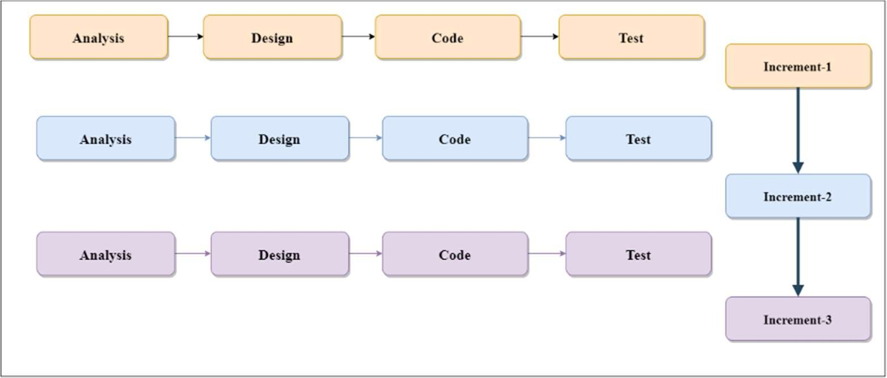
Figure 3.1: Incremental Model

Cost Estimation

Software Cost Estimation

For cost estimation, the COCOMO Model (Constructive Cost Estimation Model) is used.
Table 3.2: COCOMO model coefficients

Software Category | a | b | c | d
Organic | 2.4 | 1.05 | 2.5 | 0.38
Semi-detached | 3.0 | 1.12 | 2.5 | 0.35
Embedded | 3.6 | 1.20 | 2.5 | 0.32

As our team consist of inexperienced developers, we estimated the cost as per the semi- detached model. The summary of cost estimation is shown below.
Software Project Category: Semi Detached
Estimated Lines of Code (LOC): 100 LOC = 0.1 KLOC
Effort applied = a*(KLOC)b [Person-Months] = 3(0.1)1.12 = 0.227 PM (Person-Months) Development Time = c*(Effort)d = 2.5(0.227)0.35 = 1.48 months / 44 days

3.8 Project Scheduling using Gantt chart
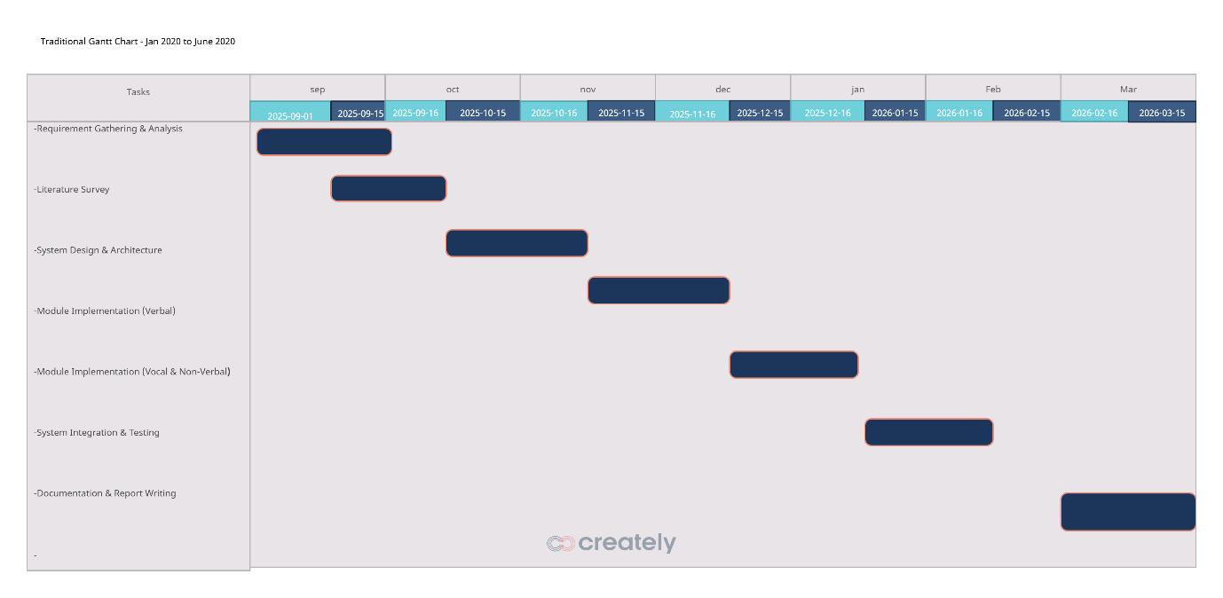

Figure 3.2: Gantt chart
The Gantt chart shows the project scheduling. Gantt chart shows the start and finish date of the project. Our project phases will be completed as per the prescribed time schedule in the above Gantt chart Figure 3.2. The starting date was 26/04/2022 and the project was completed on 22/07/2022.

CHAPTER 4 METHODOLOGY

Proposed System
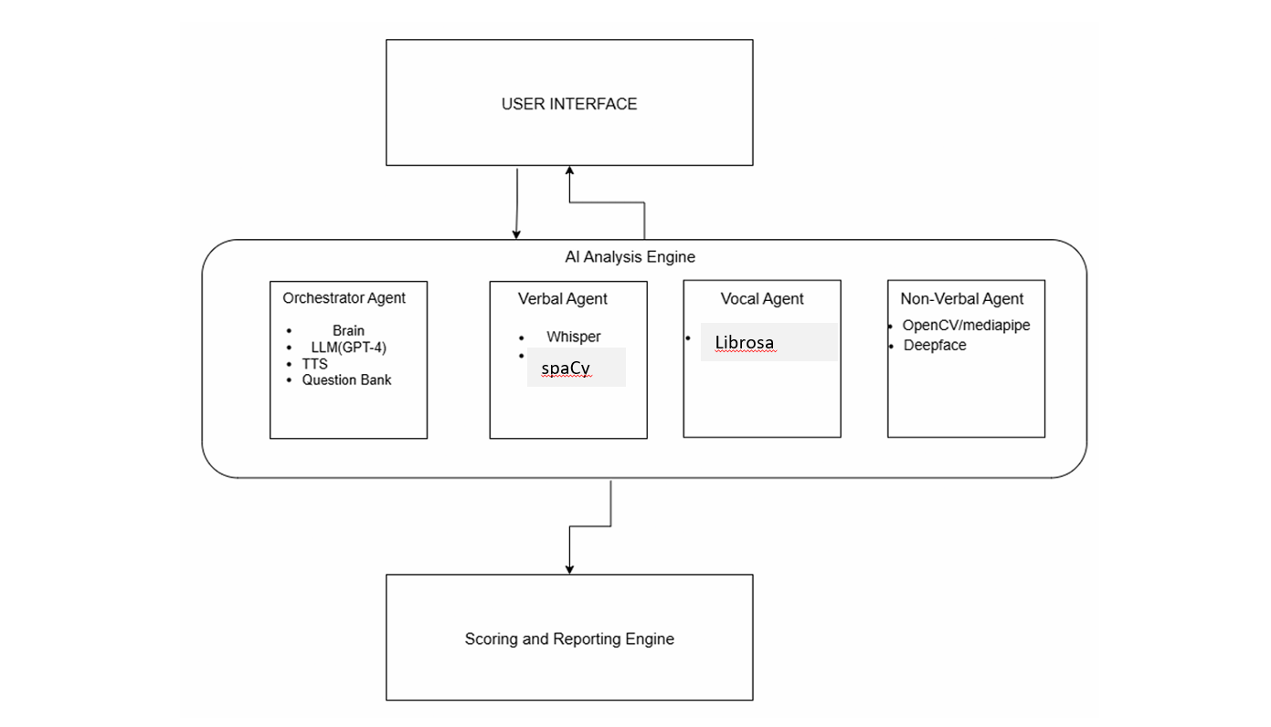
The proposed system is designed with a modular, agent-based architecture to ensure scalability and maintainability. It consists of a user-facing frontend, a central AI Analysis Engine, and a backend Scoring & Reporting Engine. This design allows each specialized agent within the AI Engine to process data in parallel, focusing on a specific analysis task before their outputs are fused for a final, comprehensive evaluation.

Figure 4.1: System Architecture

Modular Decomposition
The proposed system consists of both hardware and software module. The hardware module includes various components like Arduino UNO, ISD1820 recording module, Speaker and a PIR sensor. The software module consists of Arduino code which is an embedded C program to control the associated hardware components.

- Frontend / User Interface
- Function: To provide a web-based interface where the candidate interacts with the AI interviewer. It captures and streams the user's video and audio to the backend in real-time.
- Technology: The interface is built using a modern JavaScript framework like React or Vue.js for a responsive user experience.
    - AI Analysis Engine
This is the core of the system and contains four specialized agents that work in parallel.
  - Orchestrator Agent (The AI Interviewer)
  - Function: Acts as the "brain" of the operation, managing the entire interview process from greetings to asking questions and ending the session.
  - Technology:
- Large Language Model (LLM): Uses the Llama 3 8B model to generate natural, conversational dialogue.
- Text-to-Speech (TTS): Uses Piper TTS to convert the LLM's text responses into spoken words for the candidate to hear.
- Question Bank: Pulls from a pre-selected database of interview questions.

- B. Verbal Analysis Agent (The Scribe & Analyst)
- Function: To understand what the candidate is saying by transcribing their speech and analyzing the content for accuracy.
- Technology:
- Speech-to-Text (STT): Employs Whisper to accurately transcribe the candidate's spoken answer into text.
- NLP and Keyword Matching: Uses spaCy for robust Natural Language Processing tasks.
- Semantic Comparison: Uses a sentence transformer, specifically all-MiniLM-L6-v2, to compare the semantic similarity between the candidate's answer and a predefined set of correct answers
- C. Vocal Analysis Agent (The Tone Analyzer)
- Function: To analyze how the candidate is speaking by processing the raw audio stream to detect indicators of stress and confidence.
- Technology:
  - Uses the Librosa library to extract acoustic features like pitch, pace, and volume from the audio signal.
  - The output is a score based on the candidate's vocal confidence.

- D. Non-Verbal Analysis Agent (The Body Language Expert)
- Function: To analyze the candidate's body language, facial expressions, and overall appearance from the video feed.
- Technology:
  - Emotion Recognition: Uses Deepface for analyzing facial expressions to recognize emotions.
  - Appearance Analysis: Analyzes aspects of the candidate's appearance, such as professional attire (e.g., wearing a shirt), which may involve custom-trained models.
  - The output is a score based on confidence derived from facial expressions and body language.

    - Scoring and Reporting Engine
- Function: This component gathers the individual scores from all the specialized agents, combines them, and generates the final report.
- Technology: It is a backend service that applies the scoring logic and generates a report in Word format. The report includes the user's name, individual scores for accuracy and confidence, and a final total score.

  - Scoring System
The scoring system of the AI-powered Interview Assessment Tool is designed to aggregate the outputs from the analysis agents—Verbal, Vocal, and Non-Verbal—into a final, comprehensive evaluation that reflects a candidate’s overall performance during a mock interview. This system ensures an objective, data-driven assessment by integrating diverse metrics into a structured framework, aligning with the project’s goal of standardizing and streamlining the initial screening phase. The scoring is divided into two main parts—Answer Accuracy and Confidence—each contributing distinct dimensions to the evaluation, which are then combined to yield a total score.
The Answer Accuracy component, derived from the Verbal Agent’s analysis, assesses the quality and relevance of the candidate’s verbal responses. This part focuses on the content of the answers, evaluating factors such as semantic coherence, depth of knowledge, and alignment with the question’s intent. The Verbal Agent employs advanced NLP techniques, including the all-MiniLM-L6-v2 sentence transformer for semantic similarity (weighted at 80%) and spaCy for keyword matching (weighted at 20%), to generate a score out of a maximum of 100 points. This weighted approach ensures that understanding and context are prioritized while still recognizing the importance of specific terminology, providing a balanced measure of intellectual capability.
The Confidence component, aggregating outputs from the Vocal and Non-Verbal Agents, evaluates the candidate’s communication style and engagement level, contributing up to 100 points. The Vocal Agent analyzes paralinguistic features such as pitch, pace, volume, and filler word usage (using Librosa and an Audio Spectrogram Transformer) to produce a Vocal Confidence score, which accounts for 60% of the Confidence total (maximum 60 points). The Non-Verbal Agent assesses visual cues like facial expressions, eye contact, and posture (using OpenCV, MediaPipe, and Deepface) to generate a Non-Verbal Confidence score, contributing 40% (maximum 40 points). This division reflects the relative importance of auditory and visual cues in projecting confidence, with the scores fused using a weighted algorithm to ensure a holistic assessment of interpersonal skills.
The final Grand Total score is calculated by summing the Answer Accuracy score (maximum 100 points) and the Confidence score (maximum 100 points), resulting in a maximum possible score of 200 points. For instance, a candidate with an Answer Accuracy of 75 points and a Confidence score of 85 points would achieve a Grand Total of 160 points. This cumulative scoring system integrates cognitive and behavioral evaluations, providing hiring managers with a comprehensive metric to inform decisions. The process is supported by the Scoring & Reporting Engine, which applies the weighted fusion and generates detailed reports, ensuring consistency and transparency across evaluations.
4.3.1 Scoring Logic
Part 1: Answer Accuracy (Maximum 100 Points)
This section details the evaluation framework for the Answer Accuracy component of the AI-powered Interview Assessment Tool, which contributes a maximum of 100 points to the candidate’s overall performance score. The Answer Accuracy score is designed to assess the quality and relevance of the candidate’s verbal responses during the mock interview, focusing on both the meaning conveyed and the presence of key concepts. This score is calculated as a weighted average of two distinct metrics—Semantic Score and Keyword Score—derived from advanced natural language processing (NLP) techniques, ensuring a balanced and robust evaluation of content mastery.
- Semantic Score: This component, weighted at 80% of the total Answer Accuracy score, is generated using the all-MiniLM-L6-v2 sentence transformer, a state-of-the-art model from the Sentence-BERT family. The Semantic Score evaluates the overall meaning and contextual relevance of the candidate’s response by comparing it to an ideal answer or question rubric embedded in the system’s Question Bank. The model computes cosine similarity between sentence embeddings of the candidate’s transcribed text (processed via Whisper) and the expected response, capturing nuanced semantic relationships beyond exact word matches. For instance, a response paraphrasing the correct concept would score highly, even without identical phrasing. This raw similarity score is normalized and scaled to contribute up to 80 points, reflecting the heavy weighting given to understanding and coherence, which are critical for assessing intellectual capability in diverse interview scenarios.
- Keyword Score: This component, weighted at 20% of the total Answer Accuracy score, is generated using spaCy, a robust NLP library. The Keyword Score measures the presence and frequency of specific keywords or phrases identified as essential to the question, as defined by the Question Bank (e.g., technical terms for coding questions or soft skills like “teamwork” for behavioral ones). SpaCy performs tokenization, part-of-speech tagging, and entity recognition on the transcribed text to identify matches, assigning a score based on the proportion of required keywords present. For example, a response containing 80% of expected keywords might yield a high partial score. This score is scaled to contribute up to 20 points, acknowledging the importance of precise terminology while subordinating it to semantic understanding, aligning with the system’s goal of evaluating both depth and accuracy.
The final Answer Accuracy score is computed by combining the Semantic Score (up to 80 points) and Keyword Score (up to 20 points) using their respective weights: $\text{Answer Accuracy}=(0.8×\text{Semantic Score})+(0.2×\text{Keyword Score})$For example, a Semantic Score of 75/80 and a Keyword Score of 18/20 would yield: $\text{Answer Accuracy}=(0.8×75)+(0.2×18)=60+3.6=63.6\text{ point}\text{s}$This weighted average ensures a comprehensive assessment, prioritizing semantic depth while retaining sensitivity to key concepts. The score integrates with the Confidence score (from Part 2) to form the Grand Total (maximum 200 points), supporting the project’s objective of providing an objective, data-driven evaluation for standardized hiring decisions.

- Part 2: Confidence (Maximum 100 Points)
This section outlines the evaluation framework for the Confidence component of the AI-powered Interview Assessment Tool, which contributes a maximum of 100 points to the candidate’s overall performance score. The Confidence score is a composite metric derived from the integration of vocal and non-verbal analyses, reflecting the candidate’s communication style and engagement level during the mock interview. This dual-assessment approach ensures a holistic evaluation, capturing both auditory and visual cues that are critical for assessing professional demeanor and interpersonal skills in a recruitment context.
- 2a: Vocal Confidence (Maximum 60 Points) The Vocal Confidence score, capped at 60 points, represents 60% of the total Confidence score and is derived exclusively from the Vocal Agent’s analysis. This agent evaluates key paralinguistic features extracted from the audio stream, including pace (words per minute), pitch (fundamental frequency variation), volume (amplitude levels), and the frequency of filler words (e.g., "um," "ah"). Using tools like Librosa and an Audio Spectrogram Transformer (AST)-based model, the Vocal Agent generates a raw score based on predefined benchmarks for confident speech (e.g., steady pace of 120-150 words per minute, minimal fillers). This raw score is then scaled to a maximum of 60 points, with adjustments for deviations (e.g., high pitch variability indicating nervousness may reduce the score). The weighting of 60% acknowledges the significant role of vocal delivery in conveying confidence and clarity, aligning with the system’s goal of assessing communication effectiveness.
- 2b: Non-Verbal Confidence (Maximum 40 Points) The Non-Verbal Confidence score, capped at 40 points, constitutes 40% of the total Confidence score and is based on the Non-Verbal Agent’s analysis of video data. This agent assesses visual cues such as emotional expressions (e.g., happiness, anxiety detected via Deepface), eye contact (gaze direction ratios using MediaPipe), posture (body pose alignment with OpenCV), and gestures (hand movement frequency). The agent generates a raw score by comparing these cues against standards for professional engagement (e.g., consistent eye contact for 60-70% of the session). This score is scaled to a maximum of 40 points, with deductions for inconsistencies (e.g., slumped posture or mismatched emotions). The 40% weighting reflects the importance of body language in non-verbal communication, complementing vocal analysis to provide a balanced confidence assessment.
- Grand Total (Maximum 200 Points) The final overall score for the candidate is the Grand Total, with a maximum of 200 points, calculated as the sum of the Answer Accuracy (from Part 1, maximum 100 points) and the combined Confidence scores (maximum 100 points). The Answer Accuracy score, derived from the Verbal Agent’s evaluation of content relevance, coherence, and sentiment, is integrated with the Confidence score to reflect both intellectual capability and interpersonal presentation. For example, a candidate might score 75 points for Answer Accuracy and 85 points for Confidence, resulting in a Grand Total of 160 points. This cumulative approach ensures a comprehensive evaluation, aligning with the project’s objective of providing an objective, standardized assessment that supports informed hiring decisions.
- Datasets for Training
To train and fine-tune the various AI models within the AI-powered Interview Assessment Tool, a diverse and carefully selected set of datasets will be utilized. These datasets are chosen to ensure robust performance across the system’s multimodal analysis capabilities—verbal, vocal, and non-verbal—while addressing real-world variations in candidate responses and behaviors. The selection process emphasizes publicly available resources, validated research corpora, and potential custom data to enhance model accuracy and relevance for recruitment scenarios.
- Interview Question Datasets (Text-Based): These datasets will be sourced from public repositories on platforms like GitHub and Kaggle, which host extensive collections of interview-related questions. The datasets include a wide range of question types—technical (e.g., coding problems from LeetCode), behavioral (e.g., situational scenarios from HR forums), and role-specific queries—spanning industries and experience levels. Preprocessing will involve categorizing questions, removing duplicates, and balancing content (e.g., equal distribution of technical and soft-skill questions) to build a comprehensive Question Bank. This dataset will fine-tune the Orchestrator Agent to generate adaptive, contextually relevant interview dialogues, ensuring coverage for diverse job roles.
- Behavioral / Psychological Interview Dataset: The DAIC-WOZ Dataset (Distress Analysis Interview Corpus - Wizard of Oz), a well-established research corpus, will be utilized to train models on detecting nuanced behavioral and psychological cues. This dataset comprises audio and video recordings of simulated clinical interviews, labeled for indicators such as distress, depression, confidence, and hesitation. It will be used to train the Verbal Agent (for response content analysis) and Vocal Agent (for speech pattern detection) to identify subtle cues like tone shifts or filler word usage, enhancing the system’s ability to assess emotional states and engagement. Ethical handling of sensitive data, including anonymization, will be prioritized during processing.
- Video Datasets with Body Language: The RAVDESS Dataset (Ryerson Audio-Visual Database of Emotional Speech and Song) will be employed to train the Non-Verbal Agent on recognizing emotional expressions from video and audio inputs. This dataset contains 7,356 files featuring actors expressing 24 emotions (e.g., happiness, sadness, anger) through facial movements, gestures, and vocalizations. The data will be used to fine-tune computer vision models (e.g., OpenCV, Deepface) for accurate emotion and body language detection, improving the agent’s ability to evaluate professionalism and attentiveness. Data augmentation techniques, such as adding background noise or varying lighting, will enhance robustness to real-world conditions.
- Custom Datasets: To address specific recruitment needs, a custom dataset may be created to train the Non-Verbal Agent to recognize professional attire. This dataset will involve collecting video footage of individuals in various dress codes (e.g., formal suits, business casual, inappropriate attire), labeled by HR experts for appropriateness based on industry standards. The dataset will be annotated for features like color coordination, fit, and formality, enabling the agent to assess visual professionalism alongside body language. This custom approach ensures the system adapts to organizational dress policies, with data collection adhering to consent and privacy regulations.
These datasets will be preprocessed (e.g., cleaned, normalized) and split into training (80%), validation (10%), and test (10%) sets to optimize model performance. Fine-tuning will incorporate domain-specific adjustments (e.g., recruitment contexts), ensuring the system delivers reliable, unbiased evaluations tailored to the hiring process.

CHAPTER 5

SYSTEM DESIGN
This chapter depicts the system model using a variety of diagrams, including the Architectural Diagram, Data Flow Diagram, Use Case Diagram, and Sequence Diagram to visualize the system's structure and behavior.

5.1 Architectural Diagram

- Description: The Architectural Diagram provides a high-level overview of the AI-powered Interview Assessment Tool’s structure, illustrating the organization and interaction of its key components. This diagram showcases a layered and modular design that facilitates scalability, maintainability, and efficient processing of multimodal data. It highlights the flow of data and control from the user interaction point through specialized analysis agents to the generation of comprehensive feedback, aligning with the system’s objective of standardizing and streamlining the initial screening phase.
The architecture is centered around the User Interface, depicted as the topmost layer, which serves as the primary point of interaction for the candidate. Built using a modern JavaScript framework like React or Vue.js, this component captures real-time video and audio streams via WebRTC and provides a responsive, web-based platform. The User Interface communicates bidirectionally with the AI Analysis Engine, transmitting raw user input (e.g., video frames at 720p and audio at 16kHz) and receiving processed outputs or real-time cues. This connection is secured with encrypted channels (e.g., HTTPS/TLS) to ensure data privacy.
The AI Analysis Engine, positioned as the core processing layer, houses four parallel agents designed to operate concurrently for efficient multimodal analysis. The Orchestrator Agent acts as the central coordinator, managing the interview flow by pulling questions from a Question Bank, generating dialogue via a Large Language Model (e.g., GPT-4), and triggering the other agents. The Verbal Agent focuses on speech-to-text transcription (using Whisper) and content analysis (using Longformer and spaCy), evaluating relevance and coherence. The Vocal Agent analyzes audio features like pitch, pace, and filler words (with Librosa and AST) to assess communication style. The Non-Verbal Agent processes video data with OpenCV, MediaPipe, and Deepface to evaluate body language and emotions. Each agent processes data independently, leveraging distributed computing (e.g., cloud microservices), and sends its output—structured as analysis scores and insights—to the next layer.
The Scoring and Reporting Engine, located at the bottom layer, receives the outputs from all agents and compiles the final feedback. This engine applies a weighted fusion algorithm (e.g., 40% verbal, 30% vocal, 30% non-verbal) to generate an overall performance score (e.g., 0-100) and creates a detailed Feedback Report. The report includes category-specific evaluations, visualizations (e.g., confidence trend charts), and actionable suggestions, which are stored securely in a Report Database and delivered back to the User Interface for the candidate or Interviewer/Admin. The architecture supports scalability through containerization (e.g., Docker) and orchestration (e.g., Kubernetes), ensuring it can handle multiple concurrent sessions without performance degradation.
The diagram is visualized with boxes representing each component, connected by arrows indicating data flow (e.g., from User Interface to AI Analysis Engine, then to Scoring and Reporting Engine). Annotations may highlight parallel processing paths and security measures, emphasizing the system’s modularity and robustness. This design reflects the project’s goal of providing an objective, automated evaluation by integrating diverse analysis streams into a cohesive output.
.
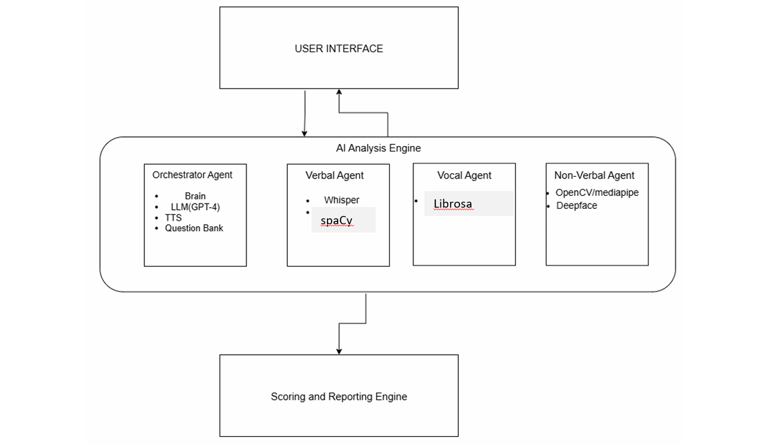
Figure 5.1: System Architecture

5.2 Data Flow Diagram (DFD)

Description: The Data Flow Diagram (DFD) provides a detailed illustration of how data flows through the AI-powered Interview Assessment Tool, mapping the movement, processing, and storage of information across its components. This diagram offers a high-level view of the system’s data lifecycle, emphasizing the transformation of raw user inputs into actionable insights. It is structured using a context-level (Level 0) DFD, with potential expansion into Level 1 for deeper granularity, to depict the interactions between external entities, processes, data stores, and data flows.
The DFD begins with the Candidate as the primary external entity, who provides User Input in the form of real-time video and audio streams during a mock interview. This input is captured through the User Interface (e.g., a web-based frontend using React or Vue.js), which serves as the entry point. The User Input data flow—comprising video frames (e.g., 720p resolution) and audio signals (e.g., 16kHz sampling rate)—is transmitted securely via WebRTC to the central AI-Based Mock Interview Evaluator process. This process represents the core system functionality, encompassing the AI Analysis Engine and its specialized agents (Orchestrator, Verbal, Vocal, and Non-Verbal).
Within the AI-Based Mock Interview Evaluator, the data undergoes parallel processing. The Verbal Agent transcribes audio to text using Whisper and analyzes content with Longformer and spaCy, producing verbal analysis data. The Vocal Agent extracts features like pitch and pace with Librosa and AST, generating vocal analysis data. The Non-Verbal Agent processes video with OpenCV, MediaPipe, and Deepface to assess body language, yielding non-verbal analysis data. These intermediate data flows are temporarily stored in a Processing Buffer data store, ensuring synchronization and handling delays (e.g., 5-10 seconds per analysis). The Orchestrator Agent coordinates this parallel processing, pulling questions from a Question Bank data store to guide the interview flow.
The processed data from all agents is then fused using a decision-level algorithm and sent to the Scoring & Reporting Engine process. This engine aggregates the analysis results, applies a weighted scoring model (e.g., 40% verbal, 30% vocal, 30% non-verbal), and generates a Feedback Report. The report, which includes an overall score (e.g., 0-100), category breakdowns, and actionable feedback, is stored in a Report Database data store for security and retrieval. Finally, the Feedback Report is delivered as a data flow back to the Candidate and optionally to the Interviewer/Admin (another external entity) via the User Interface, supporting both candidate self-assessment and hiring decisions.
The DFD is depicted with circles or ovals for processes, rectangles for external entities, open-ended rectangles for data stores, and arrows for data flows, labeled with descriptive names (e.g., "User Input," "Verbal Analysis Data"). Annotations may indicate data volume (e.g., MBs per minute) or security measures (e.g., encrypted transmission). This diagram highlights the system’s modularity and data-driven nature, aligning with the project’s goal of standardizing and streamlining the initial screening phase through efficient data processing and delivery.
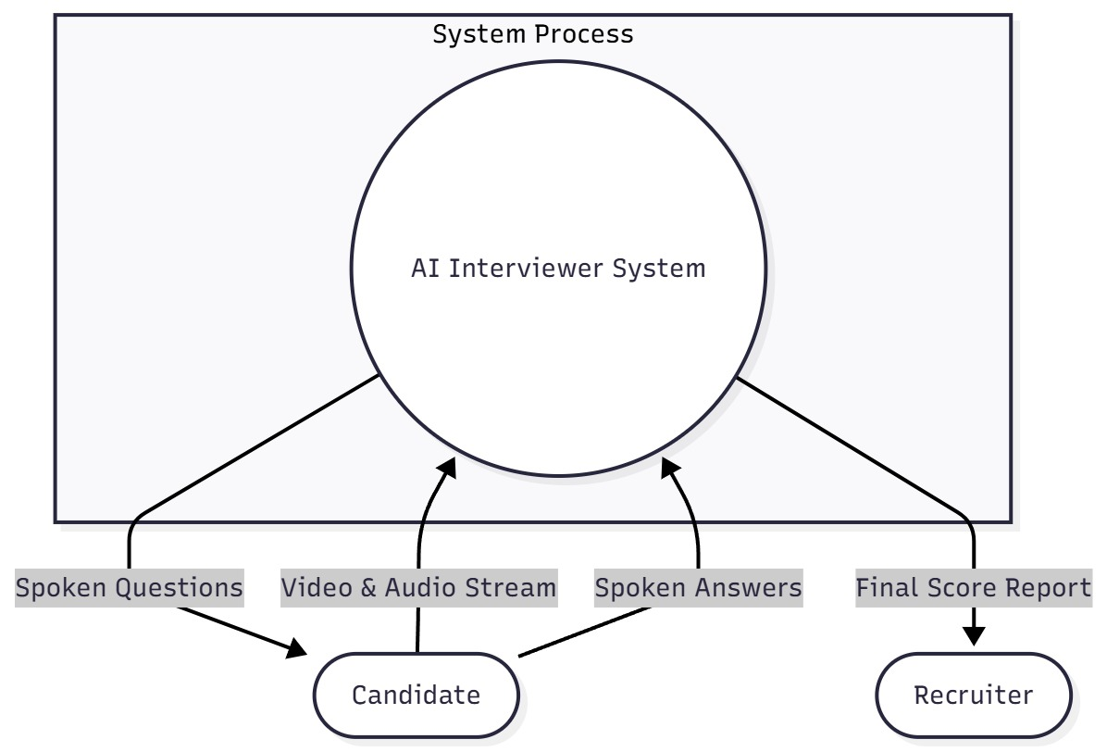

Figure 5.2: Data Flow Diagram

5.3 Use Case Diagram
Description: The use case diagram provides a visual representation of the interactions between the actors—namely the Candidate and the Interviewer/Admin—and the AI-powered Interview Assessment Tool. This diagram outlines the functional requirements and the system’s capabilities from the perspective of these actors, illustrating how they engage with the system to achieve specific goals. The primary focus is on the candidate’s experience, with additional use cases reflecting administrative oversight, ensuring the system supports both the assessment process and its management.
The diagram centers on the System (labeled as "AI Interview Assessment Tool"), which encapsulates the core functionalities. The Candidate, the primary actor, interacts with the system through two key use cases. The first use case, Start a Mock Interview, represents the candidate’s initiation of a simulated interview session. This involves logging into the web-based User Interface, selecting a role-specific interview template, and allowing the system to capture real-time video and audio streams for analysis. The process is supported by the AI Analysis Engine, which dynamically poses questions and processes responses, providing an interactive experience. The second use case, Receive a Feedback Report, follows the interview completion, where the candidate accesses a detailed, data-driven report generated by the Scoring & Reporting Engine. This report includes an overall score (e.g., 0-100), category-wise evaluations (verbal, vocal, non-verbal), and personalized feedback (e.g., suggestions for improving eye contact), delivered via the User Interface as a downloadable PDF or interactive dashboard.
The Interviewer/Admin, a secondary actor with administrative privileges, interacts with the system through additional use cases to oversee and manage the process. These include Manage Interview Templates, where the admin can create, edit, or delete question banks and role-specific settings within the Orchestrator Agent’s database, and Review Candidate Reports, allowing the admin to access and analyze aggregated candidate data for hiring decisions. These use cases are supported by the backend Scoring & Reporting Engine, ensuring secure access through role-based authentication.
The diagram is structured with ovals representing use cases, stick figures for actors, and lines connecting actors to their associated use cases, indicating direct interactions. Relationships such as "extends" or "includes" may be used (e.g., "Receive a Feedback Report" includes data aggregation steps), with annotations clarifying preconditions (e.g., user login) and post-conditions (e.g., report generation). The design reflects the system’s modularity, with the AI Analysis Engine and Scoring Engine as internal subsystems supporting these interactions. This visualization aligns with the project’s objective of standardizing and streamlining the initial screening phase, offering a clear roadmap for candidate engagement and administrative control.

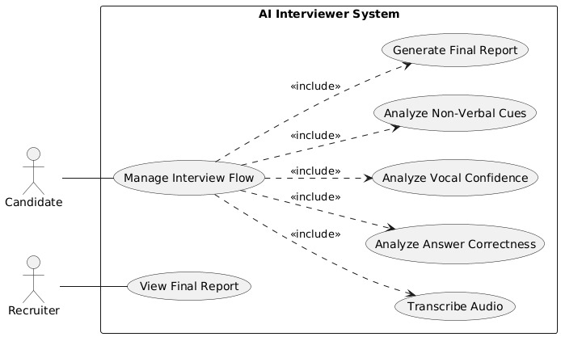

Figure 5.3: Use Case Diagram

5.4 Sequence Diagram
- Description: The sequence diagram illustrates the temporal sequence of interactions between the key components of the AI-powered Interview Assessment Tool, providing a clear visualization of the flow of data and control from initiation to completion. This diagram captures the dynamic behavior of the system as it processes a candidate’s interview, highlighting the collaboration between the User Interface, AI Analysis Engine, its specialized agents (Verbal, Vocal, and Non-Verbal), and the Scoring & Reporting Engine. The purpose is to depict how user actions trigger a cascade of automated processes, ensuring a structured and efficient evaluation pipeline.
The sequence begins with the User initiating an action, such as starting a simulated interview, through the User Interface (e.g., a web-based frontend built with React or Vue.js). The User Interface sends a request to the AI Analysis Engine, signaling the start of the session and streaming real-time video and audio data via WebRTC. Upon receiving this input, the AI Analysis Engine acts as the orchestrator, distributing the data to its three specialized agents for parallel processing. The Verbal Agent processes the transcribed text for content analysis (e.g., using Whisper and Longformer), the Vocal Agent analyzes audio features like pitch and pace (e.g., with Librosa and AST), and the Non-Verbal Agent evaluates video cues such as facial expressions and eye contact (e.g., with OpenCV and Deepface). Each agent operates concurrently, returning its respective analysis results—scores and insights—to the AI Analysis Engine.
Next, the AI Analysis Engine forwards these individual outputs to the Scoring & Reporting Engine, which aggregates the data using a weighted fusion algorithm (e.g., 40% verbal, 30% vocal, 30% non-verbal). The Scoring Engine computes an overall performance score (e.g., 0-100) and generates a comprehensive report, including category breakdowns and actionable feedback. This report is then transmitted back through the AI Analysis Engine to the User Interface, where it is displayed or made available for download by the User. The diagram includes annotations for key interactions, such as data streaming, processing delays (e.g., 5-10 seconds per analysis), and secure data transmission (e.g., encrypted channels), ensuring clarity on timing and security considerations.
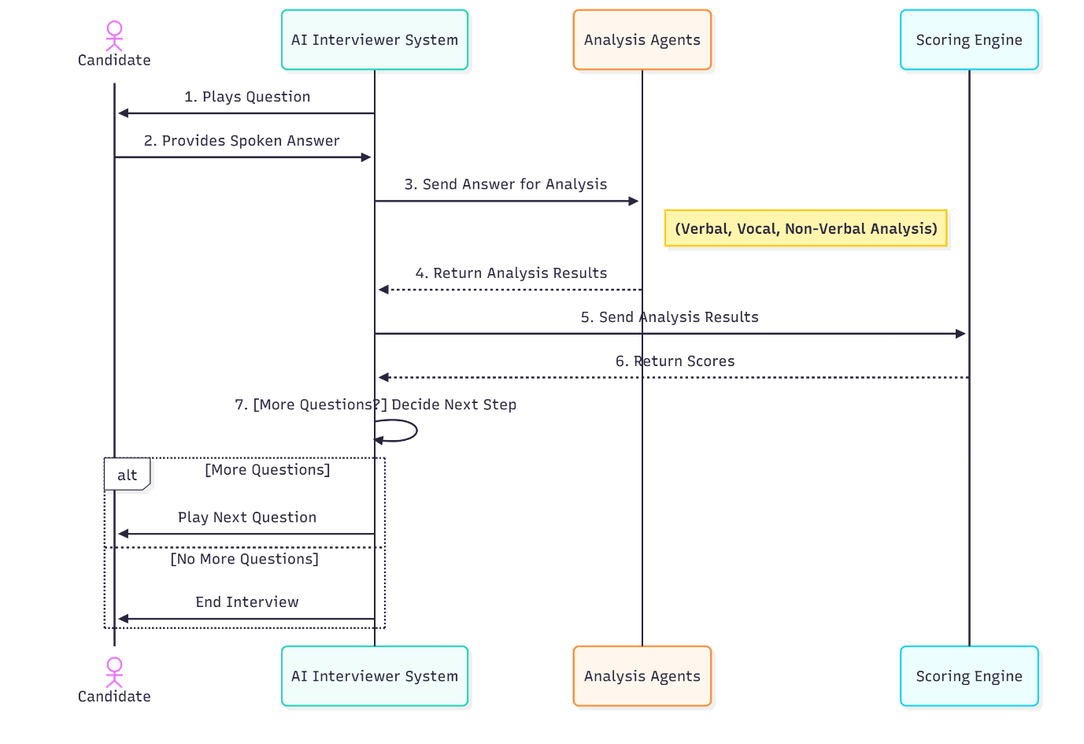
The sequence diagram is structured vertically, with time progressing downward, and horizontally across components, showing synchronous and asynchronous calls. Lifelines represent active instances (e.g., User, User Interface, AI Analysis Engine), with messages (e.g., "Start Interview," "Process Video") indicating method calls or data flows. Return messages (e.g., "Analysis Results," "Final Report") complete the cycle. This visualization underscores the system’s modularity and real-time capability, aligning with the project’s goal of standardizing and streamlining the initial screening phase while maintaining an interactive user experience..

Figure 5.4: Sequence Diagram

REFERENCES
[1] Rai, N. S., Abhiram, K. R., Adithya, P., & Hrithik, N. R. (2024). AI Based Interview Evaluator: An Emotion and Confidence Classifier. International Journal of Advanced Research in Computer and Communication Engineering, 13(4), 747-753. DOI: 10.17148/IJARCCE.2024.134109.
This paper proposes a comprehensive AI system for objective job interview assessments, leveraging machine learning, computer vision, and natural language processing to analyze video and audio inputs. It employs Deepface and Haar Cascade models for detecting facial expressions and emotional cues, Google Speech Recognition for speech-to-text conversion to evaluate communication and knowledge, and a Random Forest Classifier for confidence assessment based on speech patterns like pitch and pace. The system integrates a neural network-based chatbot for interactive follow-ups, simulating real interviews. Key advantages include bias reduction and data-driven insights for hiring, though it notes dependencies on input quality and training data diversity.
[2] Golande, S. V., Dandage, P., Jadhav, A., Mohite, P., & Shahane, A. (2025). MOCK INTERVIEW EVALUATOR POWERED BY AI. Excel International Journal of Technology, Engineering & Management, 12(2), 80-87.
This article describes an AI-driven mock interview platform for skill development, focusing on facial expression analysis via computer vision, voice modulation and sentiment analysis for tone evaluation, and NLP for keyword matching in responses. It generates personalized feedback on emotional states and confidence, suitable for educational and professional preparation. The methodology emphasizes multimodal integration for verbal and non-verbal cues, with advantages in providing practice opportunities and reducing bias. Limitations include reliance on diverse training data to prevent prejudices and potential oversight of creative responses due to keyword focus.
[3] Yan, J., Li, P., Du, C., Zhu, K., Zhou, X., Liu, Y., & Wei, J. (2024). Multimodal Emotion Recognition Based on Facial Expressions, Speech, and Body Gestures. Electronics, 13(18), 3756. https://doi.org/10.3390/electronics13183756.
The study focuses on trimodal emotion recognition using GEMEP and Polish databases, proposing feature extraction (e.g., CNN/ResNet) and fusion methods like Supervised Least Squares Multiset Kernel Canonical Correlation Analysis (SLSMKCCA) and Sparse SLSMKCCA (SSLSMKCCA). These algorithms enhance accuracy over single-modality systems by correlating facial, speech, and gesture data, solved via alternated least squares and augmented Lagrangian. It achieves superior recognition rates, validating holistic approaches for human-computer interfaces, though noting high complexity and environmental dependencies.
[4] Beltagy, I., Peters, M. E., & Cohan, A. (2020). Longformer: The Long-Document Transformer. arXiv preprint arXiv:2004.05150.
This preprint introduces Longformer, a Transformer variant with linear-scaling attention for long sequences, combining local windowed and global attention to handle thousands of tokens. Evaluated on language modeling (text8, enwik8) and tasks like WikiHop/TriviaQA, it outperforms RoBERTa, with a Longformer-Encoder-Decoder (LED) for generative applications. It addresses quadratic complexity in standard models, enabling full-context processing without partitioning, ideal for extended documents.
[5] Gong, Y., Chung, Y.-A., & Glass, J. (2021). AST: Audio Spectrogram Transformer. arXiv preprint arXiv:2104.01778.
The paper presents AST, a purely attention-based model treating audio spectrograms as images for classification, splitting into patches with positional embeddings and using a Transformer encoder. It transfers from ImageNet-pretrained ViT, achieving SOTA on AudioSet (0.485 mAP), ESC-50 (95.6%), and Speech Commands V2 (98.1%). AST handles variable-length inputs efficiently, outperforming CNN hybrids in capturing long-range dependencies.
[6] Yang, J. (2024). Large language models privacy and security. Proceedings of the 2nd International Conference on Software Engineering and Machine Learning. DOI: 10.54254/2755-2721/76/20240584.
This conference paper reviews LLM fundamentals (e.g., BERT, GPT) and Transformer architecture, emphasizing privacy risks like data leakage and misuse in handling sensitive information. It discusses safeguards such as anonymization and secure training, advocating ethical research for sustainable AI deployment and public trust.
[7] Chang, W.-C., Yu, H.-F., Zhong, K., Yang, Y., & Dhillon, I. S. (2020). Taming Pretrained Transformers for Extreme Multi-label Text Classification. In Proceedings of the 26th ACM SIGKDD Conference on Knowledge Discovery and Data Mining (KDD '20). https://doi.org/10.1145/3394486.3403368.
The paper proposes X-Transformer for extreme multi-label classification (XMC) with millions of labels, fine-tuning models like XLNet to handle sparsity and large outputs. It achieves 77.28% prec@1 on Wiki datasets, improving over Parabel by 10.7% on product-to-query tasks, addressing computational challenges in industrial NLP.

